|  |
| --- |
|  |



**31 May 2013** **The Weekly Bulletin of Rotary Club of Kathmandu Mid-Town** **Bc-31.5/012-13**

**District : 3292 Web: www.rotarymidtown.org.np Club Id : 26776**

**MAY : Month Without Theme**

**Except July and May, all other months of a Rotary Year carry a specific theme.**

Friday, 24 May:

Guest Speaker Brenden Thomson talked on calendrics, – basics of calendar making, type of calendars – lunar based and solar based, history of calendar making - how it developed, its technicalities, processes and so on.

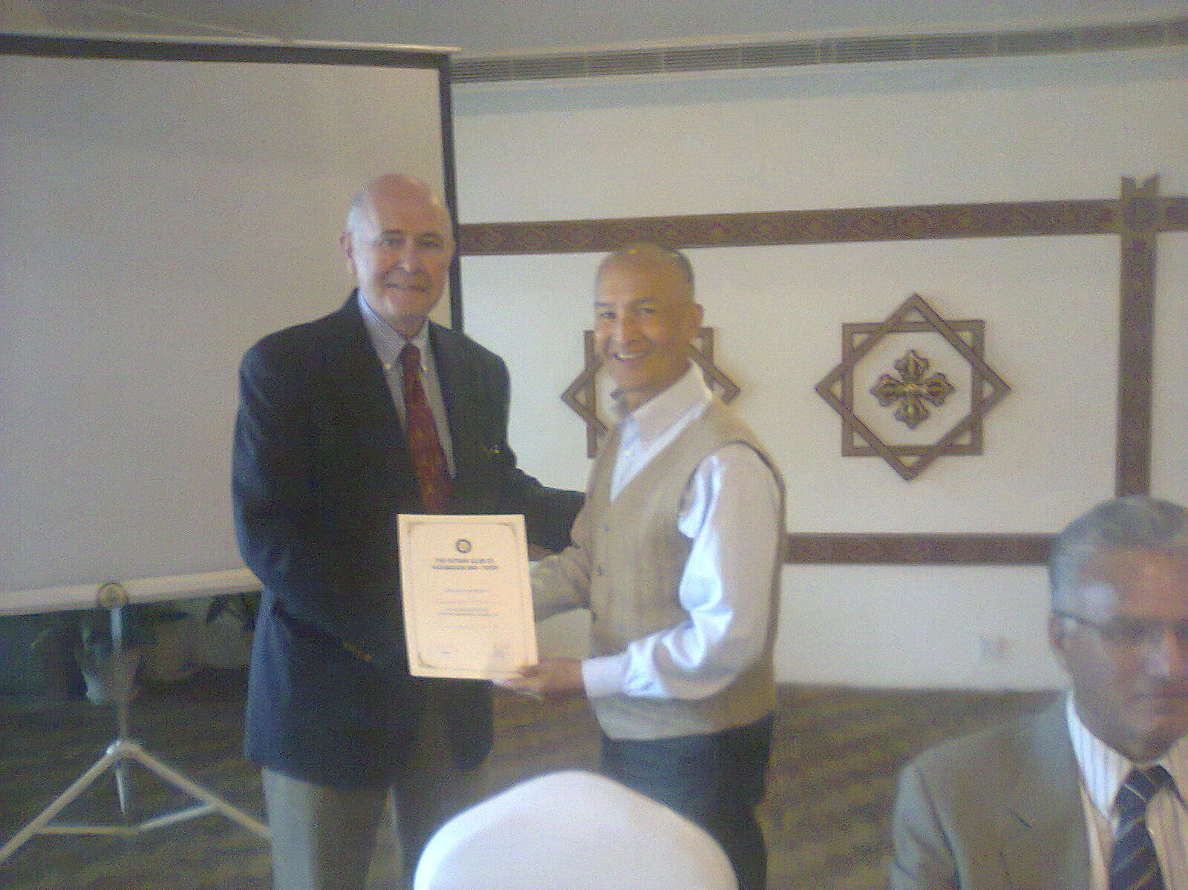

*In the picture PP Komal handing over a letter of appreciation to guest speaker Brenden Thomson*

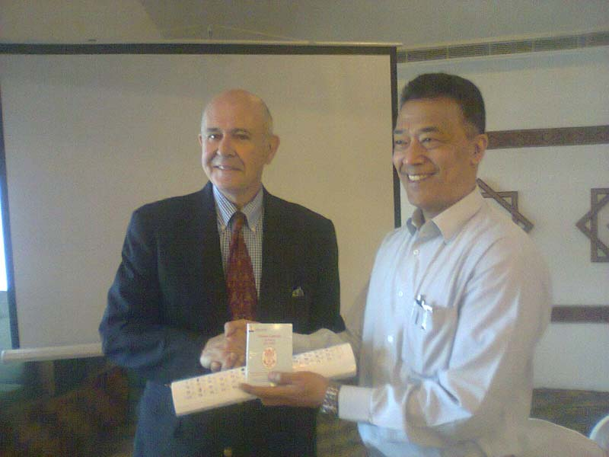

On the occasion CP Dr Roop handed over one set of Jyoti Group

calendar as a souvenir to guest speaker Brenden Thomson.

# Weekly Meetings and Programs :

|  |  |  |
| --- | --- | --- |
| Date | Program/Speaker | Program/Topics of Presentation |
| 31 May 2013 | Rtn Krishna M. Gautam | Ageing in the 21st Century: A Celebration and a Challenge |
|  |  |  |

Friday, 31 May:

Rtn Krishna M Gautam, aka *'Chatyang Master'* will be our Guest Speaker for the day, who will be talking on 'ageing in the 21st century – a celebration and a challenge.' Rtn Krishna Gautam, a graduate in animal science, worked as social economist, training specialist, institution development specialist, developed a hobby in humour/satire and published 5 books on humour and satire. Besides, he is founder member of four Institutions including Nepal Engineering College, Bhaktapur, and College of Information Technology, Gwarko. Since 2009 he has been totally devoted to work on issues of ageing population; has published 8 books on different aspects of ageing; started in 2011 e-publishing monthly bulletin – voice of senior citizens; involved in research on various aspects of ageing and elderly citizens.

**Induction of New Member:**

We added one more member in the Club !

Dr Deepak Bajracharya was inducted to the Club as a newest Rotarian in the Rotary family.

Congratulations to you, Rotarian Deepak on your induction to the Club. Welcome to the Club.

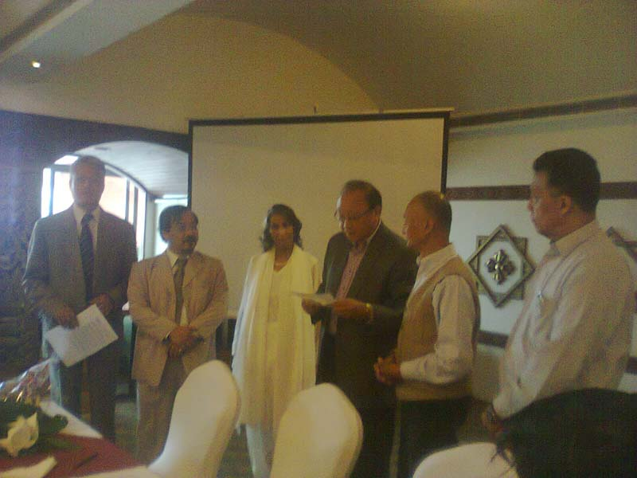

Induction in process: PP Arun inducting Dr Deepak to the Club.

CP Roop and PP Komal and PP Som look on.

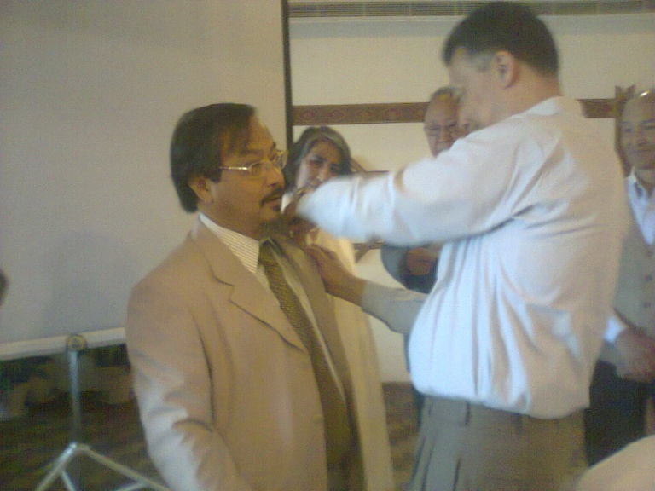 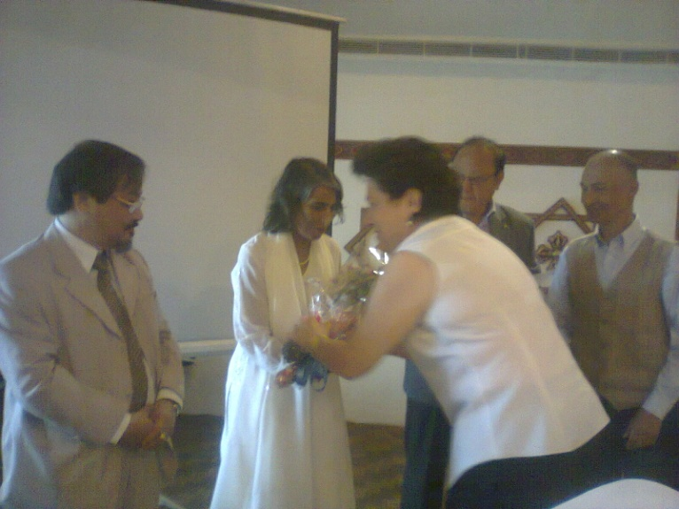

CP Roop providing Rotary pin to Dr Deepak Rtn Isabella welcoming with a bouquet of flower

**'Positive' thinkers enjoy better old age**:

Growing old is an inevitable fact of life – but some people grow old, grumpy and disillusioned; while others retain a light-hearted, optimistic outlook and a youthful zest for life.

It may seem obvious that much depends on mental attitude - those who age best, maintaining a sunny outlook and a mind that gets sharper with age, are positive thinkers who avoid needless fret and worry. But now, a study by University of Hamburg scientists has found a scientific basis for this belief.

The study, published in the journal *Biological Psychiatry*, finds that those who age ''successfully'' have a positive outlook to life and prefer emotionally gratifying experiences.

It discovered that that focusing your brain on positive thoughts, and living for the moment rather than looking too far into the future, can help maintain good mental health.

The researchers studied the ''positivity effect'' by using neuro-imaging to evaluate brain engagement in young and old adults while they performed a specialised cognitive task that included supposedly irrelevant pictures of either neutral, happy, sad or fearful faces.

During parts of the task when they didn't have to pay as much attention, the elderly subjects were significantly more distracted by the happy faces.

When this occurred, they had increased engagement in the part of the brain that helps control emotions' and this stronger signal in the brain was correlated with those who showed the greatest emotional stability.

''Integrating our findings with the assumptions of life span theories we suggest that motivational goal-shifting in healthy aging leads to a self-regulated engagement in positive emotions even when this is not required by the setting," said lead researcher Dr Stefanie Brassen.

She defined the positivity effect as ''a biased tendency towards and preference for positive, emotionally gratifying experiences''.

The results of the study suggest that staying happy and focusing on life's positives are key to people remaining mentally alert as they get older.

Dr John Krystal, the editor of *Biological Psychiatry*, said, ''The lessons of healthy ageing seem to be similar to those of resilience throughout life.

''As recently summarised in other work by doctors Dennis Charney and Steven Southwick, when coping with extremely stressful life challenges, it is critical to appraise the situation realistically but also to approach it with a positive attitude.''

*Source:* Internet News

**Research could lead to people living to 1,000 years old:**

Someone you know could live to be 1,000 years old, according to Aubrey de Grey, a Cambridge-educated biomedical gerontologist who spoke at the IdeaFestival.

“It’s just a numbers game,” de Grey told the audience in the Kentucky Center’s Bomhard Theater.

The co-author of the 2007 book “Ending Aging,” de Grey said aging is an ailment that someday could be treated through various therapies.

Even for people in good health, cells become damaged through the course of a human life, de Grey said. It’s a solvable problem, he said, by providing maintenance to damaged cells.

He cited stem cell research and using bacteria as possible means of restoring cells to their youthful state, which would lengthen life — perhaps infinitely.

“It’s all about restoring organs and tissue to the way it was before it suffered some sort of damage,” he said, comparing the process to the maintenance that can keep cars running for decades.

But it’s not as simple as keeping a healthful diet — that might only buy a few years, he said.

De Grey said the breakthrough will be finding ways to treat damaged cells, which would head off the conditions that lead to old-age deaths: heart disease, cancer, Alzheimer’s disease.

The research that could lead to these techniques is further along than most people realize, de Grey said, and could begin providing therapies within the next 25 years. Or not, he added, but the possibility exists that today’s 20-somethings could be alive in 3011.

Not only would they be alive, but they’d be able to live well, he said.

The progress toward treatments that can provide such longevity will be incremental, though. The therapies that might exist in 25 years may restore a 90-year-old’s body to a 60-year-old’s health, but would not extend life indefinitely, he said.

The key is reaching what de Grey called “longevity escape velocity” — the rate of aging combined with the rate of the medical advancements that will prolong life to before-unthinkable lengths.

An 80-year-old in 2011 hasn’t much hope of living forever, he said, but the younger a person is, the better their chances of living in an age when drastically age-prolonging therapies exist.

*Source:* Joseph Lord/The Courier Journal /Internet

**Committee Chairpersons' Column:**

**???**

**Past Presidents' Column:**

**Injustice to late Pratap Malla !**

Dr Deepak Bajracharya was proposed and his cv emailed by late Pratap Malla on 14 Apr 2011. It took 25 long months to formally induct him to the Club. Why ? The reasons are best known to Board members. Late Pratap was very enthusiastic to see Dr Deepak to be member of the Club; he asked President several times to decide one way or other – if rejected, he could join another Rotary Club. In Rotary, yes, even if one member of the club rejects somebody to be member, he or she cannot be taken to membership. If some of us (?) did not like Deepak to be member of the club, why he was inducted now? Or perhaps, he/she changed his/her opinion on Deepak! Unnecessarily, Dr Deepak had to wait 25 months ! If he was inducted on time, late Pratap could have been happier. It's injustice to late Pratap !

PP RR Shrestha

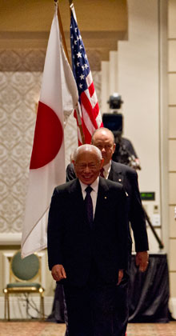

Rotary is a way for us to help more, and more effectively than we could ever do alone.

**RI President Sakuji Tanaka**

**Best Gift:**



**A Thought for the Day:**

***Mistakes increase your experience... and***

***Experience decreases your mistakes.***

***You learn from your mistakes, then others will learn from your success…***

**Great Quotes:**

***Kindness is a language which the deaf can hear,***

***and the blind can read.***

- Mark Twain

*courtesy:* Rtn Dr Isabella C Bassingana Khadka

NB: Send any informations/photos that may be of interest to the Club or Rotarians in general to

BC Editor: RR Shrestha email: rryesrr@gmail.com

## 31 May 2013 The Weekly Bulletin of Rotary Club of Kathmandu Mid-Town bc-31.5/012-13